**Project Deliverable - 2**

**Table creation and insertion of data:**

CREATE SCHEMA `Music_system` ;  
  
  
CREATE TABLE user (

user_id INT PRIMARY KEY AUTO_INCREMENT,

user_name VARCHAR(255) NOT NULL,

user_email VARCHAR(255) UNIQUE NOT NULL,

user_mobile VARCHAR(15),

user_address TEXT,

joined_date DATE

);

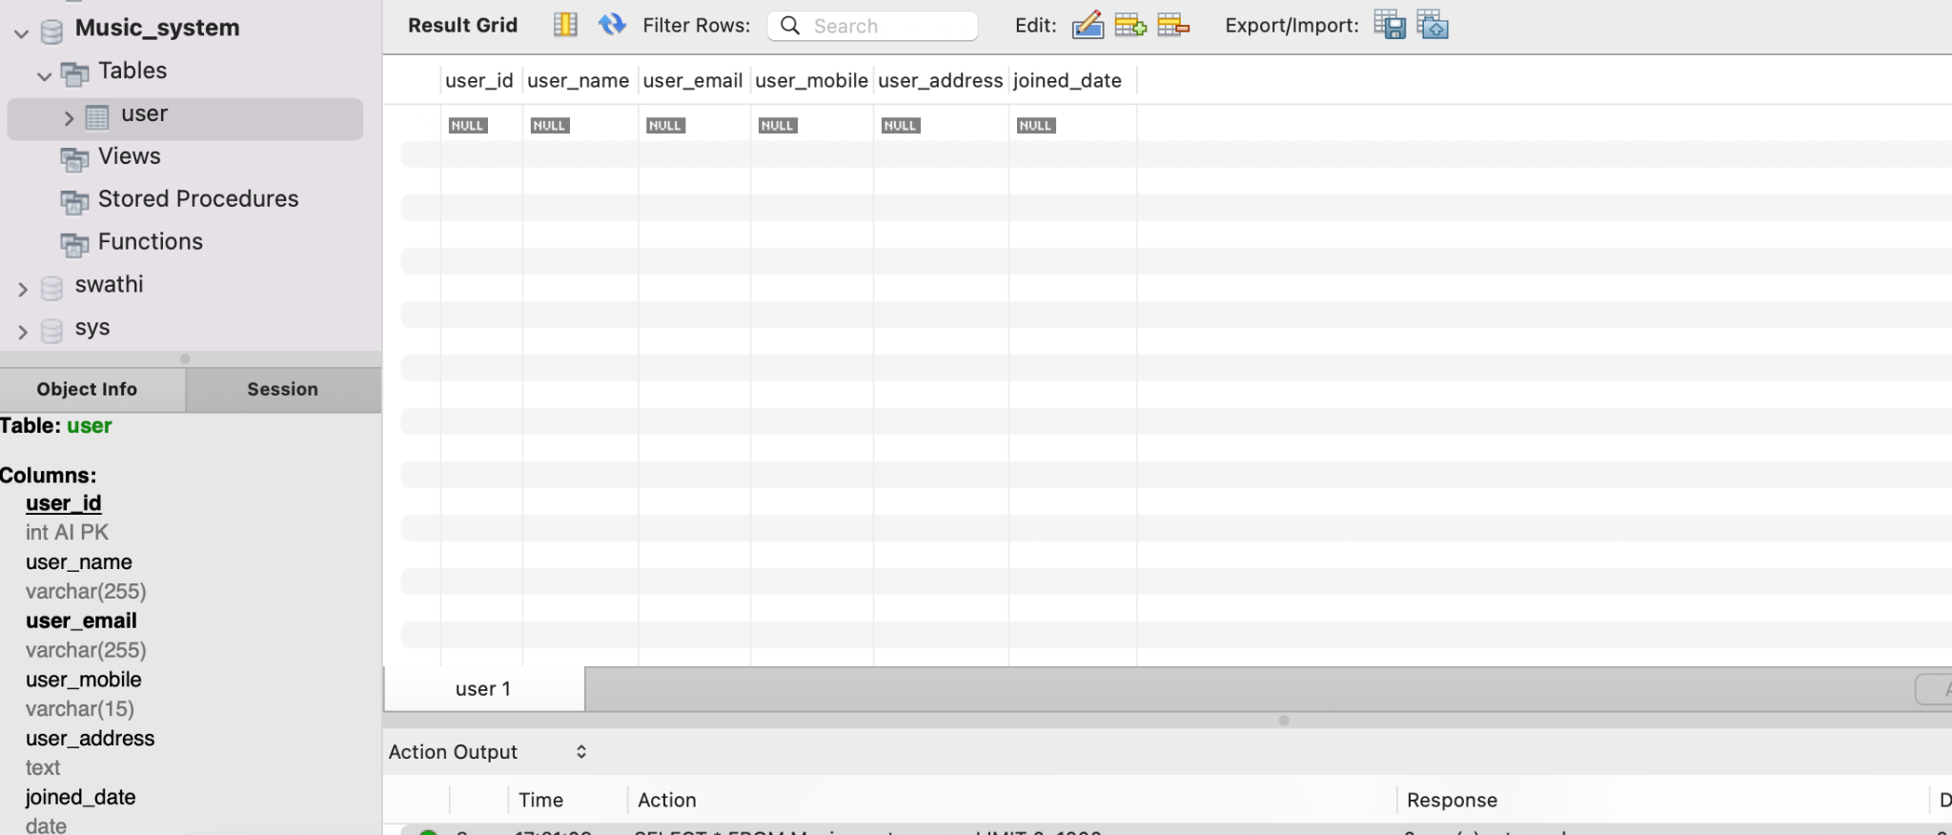

INSERT INTO user (user_name, user_email, user_mobile, user_address, joined_date)

VALUES

('Alice Johnson', 'alice@email.com', '+1-555-1234567', '123 Main St, Cityville', '2022-01-15'),

('Bob Smith', 'bob@email.com', '+1-555-9876543', '456 Elm St, Townsville', '2021-12-20'),

('Charlie Brown', 'charlie@email.com', '+1-555-5678901', '789 Oak Ave, Villageland', '2022-02-10'),

('David Wilson', 'david@email.com', '+1-555-2345678', '567 Maple Dr, Hamletown', '2021-11-05'),

('Ella Davis', 'ella@email.com', '+1-555-8765432', '890 Cedar Ln, Countryside', '2021-10-02'),

('Frank White', 'frank@email.com', '+1-555-3456789', '234 Birch Rd, Meadowville', '2022-03-25'),

('Grace Lee', 'grace@email.com', '+1-555-7654321', '456 Pine St, Hillside', '2022-01-08'),

('Harry Miller', 'harry@email.com', '+1-555-4567890', '678 Willow Ave, Riverside', '2022-04-30'),

('Ivy Turner', 'ivy@email.com', '+1-555-6543210', '123 Redwood Dr, Lakeside', '2021-12-15'),

('Jack Harris', 'jack@email.com', '+1-555-2345678', '345 Spruce Ln, Brookside', '2022-03-10'),

('Katie Clark', 'katie@email.com', '+1-555-5432109', '567 Sycamore Rd, Parkville', '2021-11-20'),

('Liam Adams', 'liam@email.com', '+1-555-8765432', '789 Oak Ave, Villageland', '2022-02-05'),

('Mia Turner', 'mia@email.com', '+1-555-3456789', '890 Cedar Ln, Countryside', '2021-10-12'),

('Noah Hall', 'noah@email.com', '+1-555-9876543', '234 Birch Rd, Meadowville', '2022-04-15'),

('Olivia Wright', 'olivia@email.com', '+1-555-1234567', '567 Maple Dr, Hamletown', '2022-01-28');

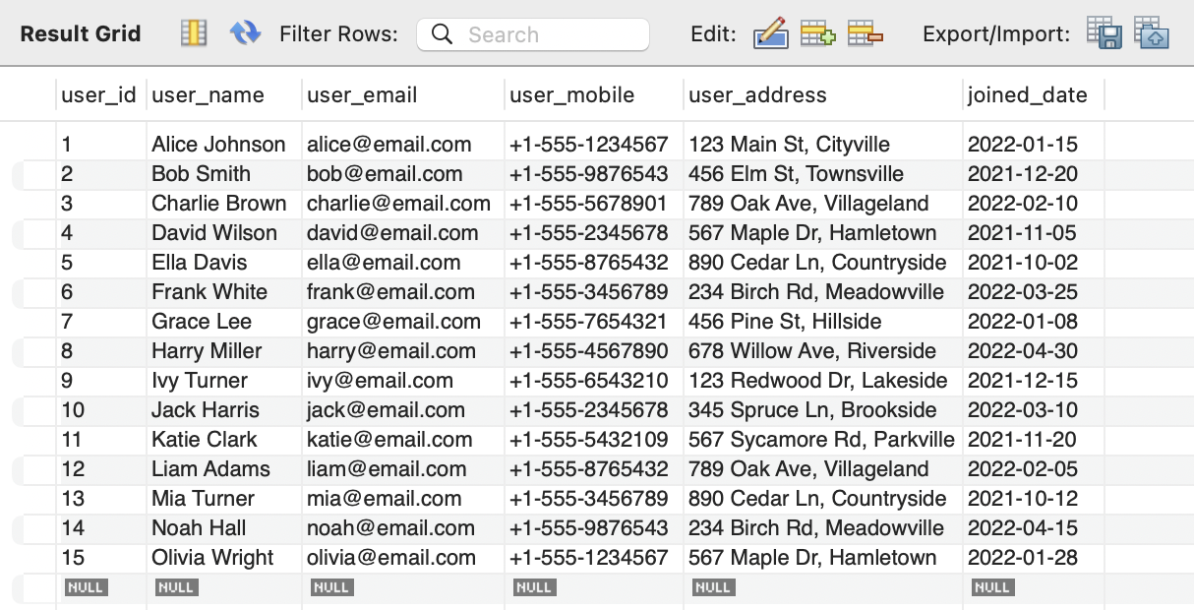

CREATE TABLE artist (

artist_id INT PRIMARY KEY,

artist_name VARCHAR(255) NOT NULL,

artist_mobile VARCHAR(15),

artist_email VARCHAR(255),

artist_gender VARCHAR(10),

user_id INT,

FOREIGN KEY (user_id) REFERENCES user(user_id)

);

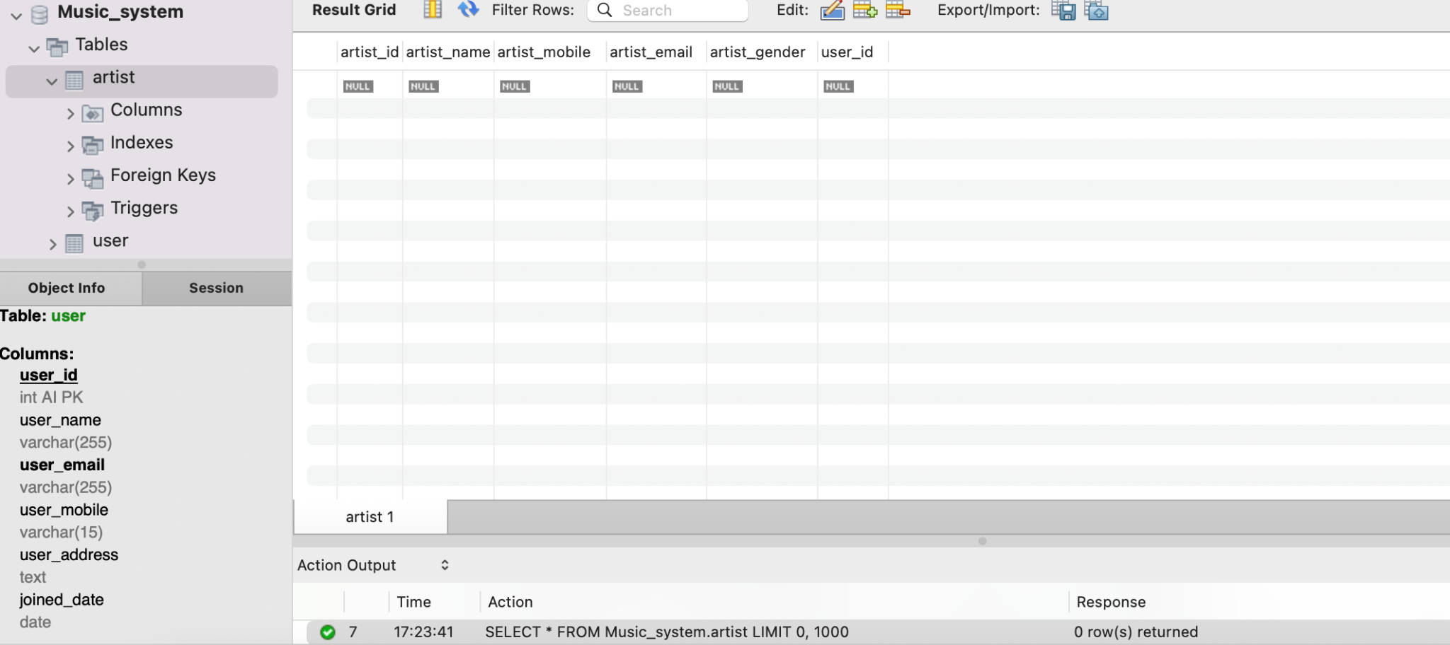

INSERT INTO artist (artist_id, artist_name, artist_mobile, artist_email, artist_gender, user_id)

VALUES

(1,'Adele', '+1-555-1111111', 'adele@email.com', 'Female', 1),

(2,'Bruno Mars', '+1-555-2222222', 'bruno@email.com', 'Male', 2),

(3,'Coldplay', '+1-555-3333333', 'coldplay@email.com', 'Mixed', 3),

(4,'Dua Lipa', '+1-555-4444444', 'dualipa@email.com', 'Female', 4),

(5,'Ed Sheeran', '+1-555-5555555', 'ed@email.com', 'Male', 5),

(6'Foo Fighters', '+1-555-6666666', 'foo@email.com', 'Mixed', 6),

(7,'Gwen Stefani', '+1-555-7777777', 'gwen@email.com', 'Female', 7),

(8,'Harry Styles', '+1-555-8888888', 'harry@email.com', 'Male', 8),

(9,'Imagine Dragons', '+1-555-9999999', 'imagine@email.com', 'Mixed', 9),

(10,'Justin Bieber', '+1-555-1010101', 'justin@email.com', 'Male', 10),

(11,'Katy Perry', '+1-555-1212121', 'katy@email.com', 'Female', 11),

(12,'Lady Gaga', '+1-555-1313131', 'ladygaga@email.com', 'Female', 12),

(13,'Maroon 5', '+1-555-1414141', 'maroon5@email.com', 'Mixed', 13),

(14,'Niall Horan', '+1-555-1515151', 'niall@email.com', 'Male', 14),

(15,'One Direction', '+1-555-1616161', '1d@email.com', 'Mixed', 15);

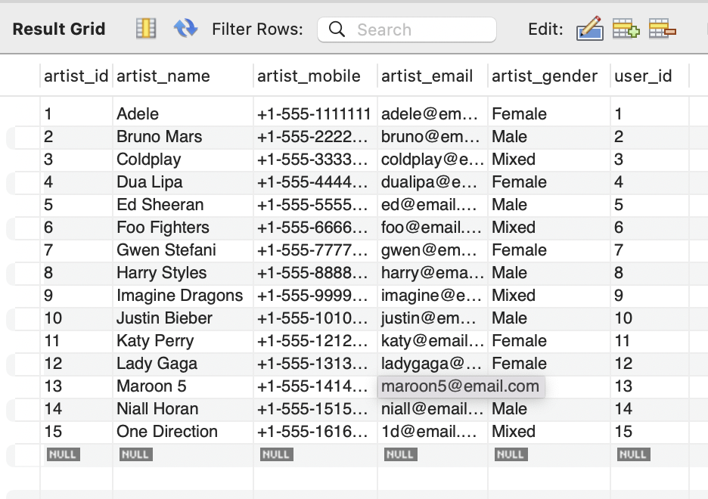

CREATE TABLE song (

song_id INT PRIMARY KEY,

Song_name VARCHAR(50),

song_type VARCHAR(50),

song_time TIME,

song_category VARCHAR(50),

artist_id INT,

FOREIGN KEY (artist_id) REFERENCES artist(artist_id)

);

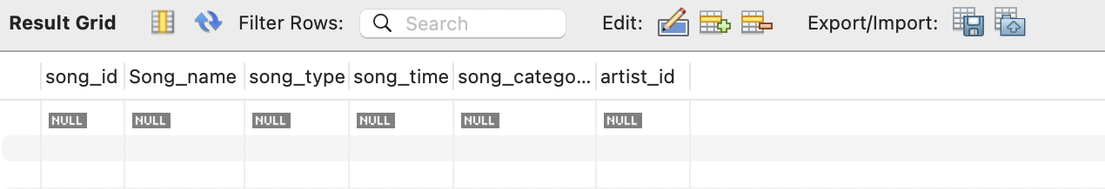

INSERT INTO song (song_id, song_name, song_type, song_time, song_category, artist_id)

VALUES

(1,'Eternal Love','Single', '3:45', 'Pop', 1),

(2,'Summer Breeze','Single', '4:20', 'R&B', 2),

(3,'Rock Revolution','Single', '3:55', 'Rock', 3),

(4,'City Light','Single', '3:30', 'Pop', 4),

(5,'Ocean Waves','Single', '4:15', 'Pop', 5),

(6,'Jazzed Up','Single', '3:40', 'Rock', 6),

(7,'Melancholy Blues','Single', '3:25', 'Pop', 7),

(8,'Dreamy Night','Single', '4:10', 'Pop', 8),

(9,'Electric Dreams','Single', '3:50', 'Rock', 9),

(10,'Harmonious Melodies','Single', '3:15', 'Pop', 10),

(11,'Mystic Echoes','Single', '3:55', 'Pop', 11),

(12,'Acoustic Serenade','Single', '3:30', 'Pop', 12),

(13,'Soulful Rhythms','Single', '4:00', 'Rock', 13),

(14,'Funky Grooves','Single', '4:05', 'Pop', 14),

(15,'Classical Elegance','Single', '3:55', 'Pop', 15);

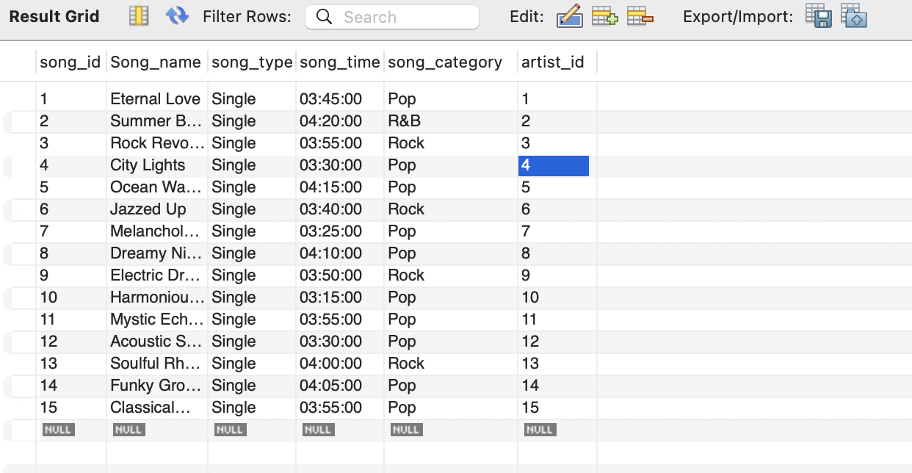

CREATE TABLE album (

album_id INT PRIMARY KEY,

album_name VARCHAR(255),

album_music_id VARCHAR(255),

album_type VARCHAR(50),

artist_id INT,

FOREIGN KEY (artist_id) REFERENCES artist(artist_id)

);

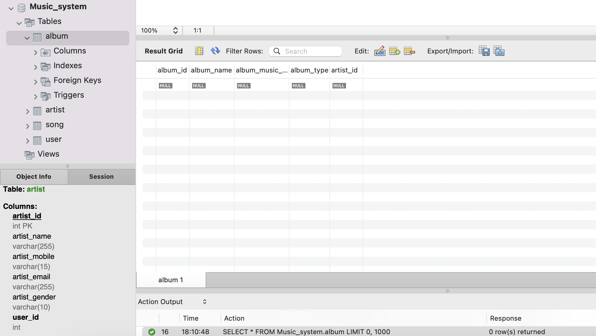

INSERT INTO album (album_id, album_name, album_music_id, album_type, artist_id)

VALUES

(1,'25', '0123456789', 'Studio', 1),

(2,'24K Magic', '9876543210', 'Studio', 2),

(3,'Everyday Life', '8765432109', 'Studio', 3),

(4,'Future Nostalgia', '7654321098', 'Studio', 4),

(5,'÷ (Divide)', '6543210987', 'Studio', 5),

(6,'Concrete and Gold', '5432109876', 'Studio', 6),

(7,'Love. Angel. Music. Baby', '4321098765', 'Studio', 7),

(8,'Fine Line', '3210987654', 'Studio', 8),

(9,'Origins', '2109876543', 'Studio', 9),

(10,'Changes', '1098765432', 'Studio', 10),

(11,'Smile', '0987654321', 'Studio', 11),

(12,'Chromatica', '987654321', 'Studio', 12),

(13,'Red Pill Blues', '876543210', 'Studio', 13),

(14,'Heartbreak Weather', '76543210', 'Studio', 14),

(15,'Take Me Home', '6543210', 'Studio', 15);

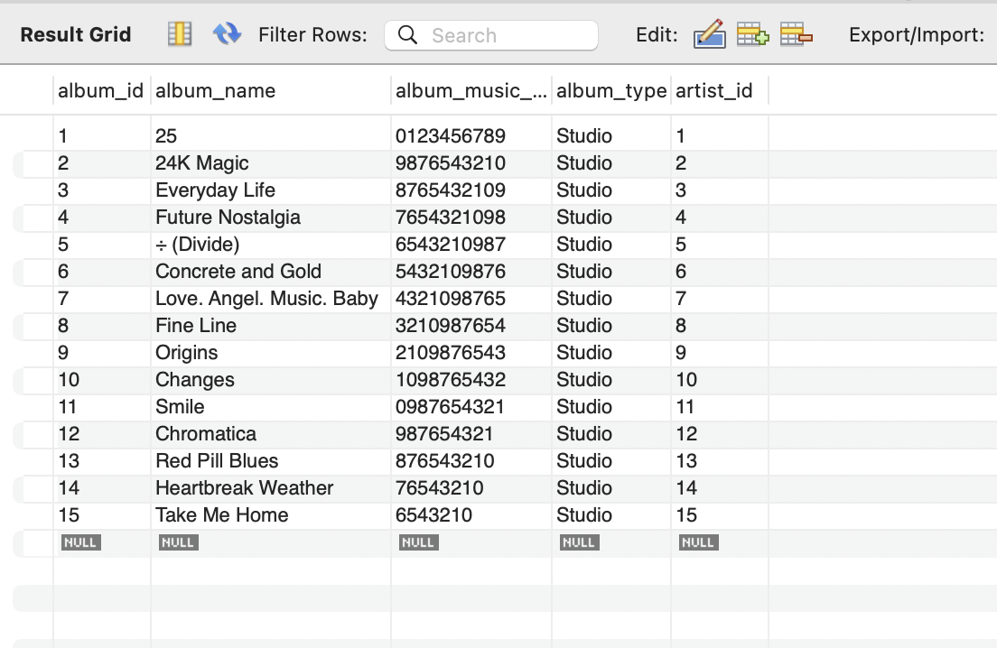

CREATE TABLE chord (

chord_id INT PRIMARY KEY,

chord_name VARCHAR(50),

chord VARCHAR(255),

created_by VARCHAR(255),

date_created DATE

);

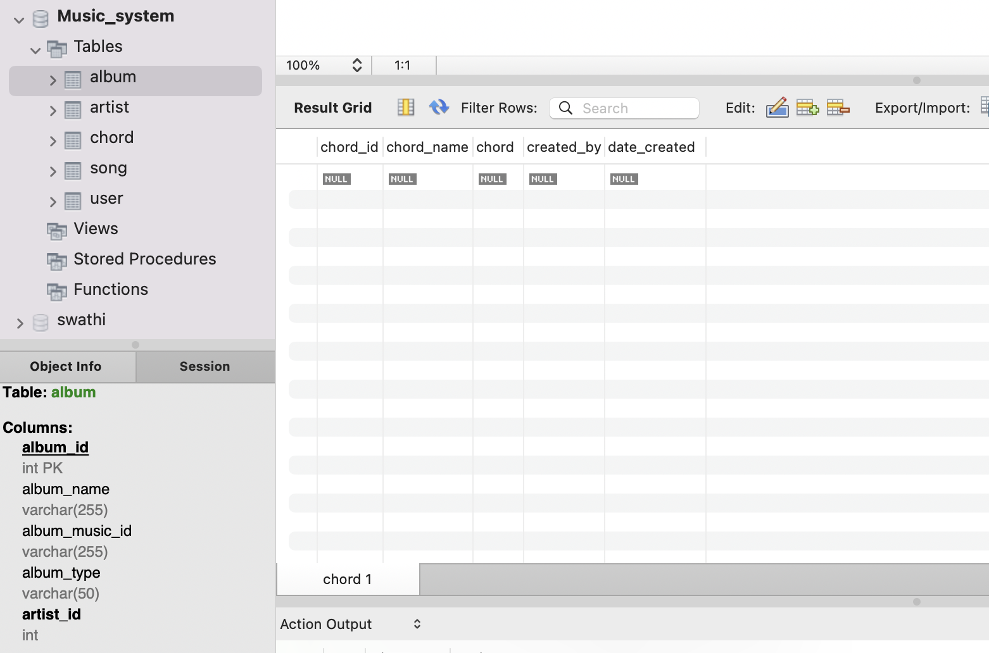

INSERT INTO chord (chord_id,chord_name, chord, created_by, date_created)

VALUES

(1,'C Major', 'C-E-G', 'Alice Johnson', '2022-01-18'),

(2,'G Major', 'G-B-D', 'Bob Smith', '2022-01-20'),

(3,'A Minor', 'A-C-E', 'Charlie Brown', '2022-01-22'),

(4,'D Major', 'D-F#-A', 'David Wilson', '2022-01-24'),

(5,'E Minor', 'E-G-B', 'Ella Davis', '2022-01-26'),

(6,'F Major', 'F-A-C', 'Frank White', '2022-01-28'),

(7,'Bb Major', 'Bb-D-F', 'Grace Lee', '2022-01-30'),

(8,'G Minor', 'G-Bb-D', 'Harry Miller', '2022-02-01'),

(9,'Am7', 'A-C-E-G', 'Ivy Turner', '2022-02-03'),

(10,'D7', 'D-F#-A-C', 'Jack Harris', '2022-02-05'),

(11,'Em7', 'E-G-B-D', 'Katie Clark', '2022-02-07'),

(12,'C# Minor', 'C#-E-G#', 'Liam Adams', '2022-02-09'),

(13,'F#7', 'F#-A-C#-E', 'Mia Turner', '2022-02-11'),

(14,'B Major', 'B-D#-F#', 'Noah Hall', '2022-02-13'),

(15,'C Minor', 'C-Eb-G', 'Olivia Wright', '2022-02-15');

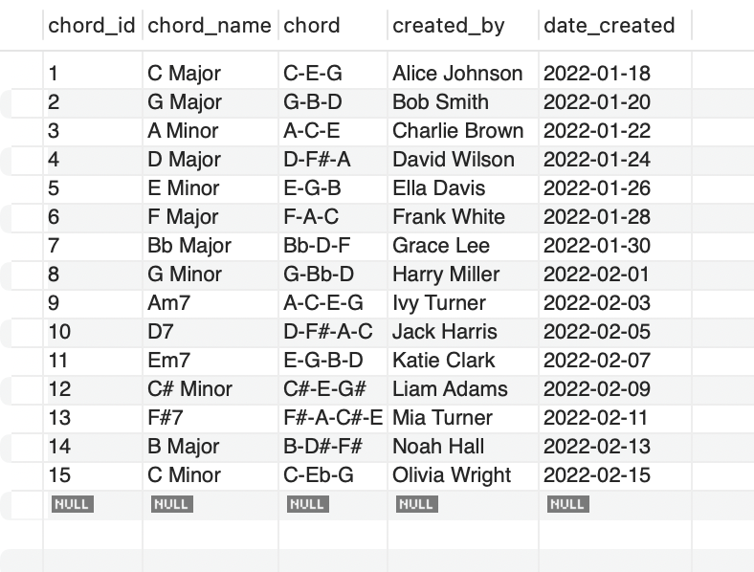

CREATE TABLE playlist (

playlist_id INT PRIMARY KEY,

playlist_name VARCHAR(255),

playlist_song TEXT, -- Store song IDs as a comma-separated list or consider a separate linking table

user_id INT,

FOREIGN KEY (user_id) REFERENCES user(user_id)

);

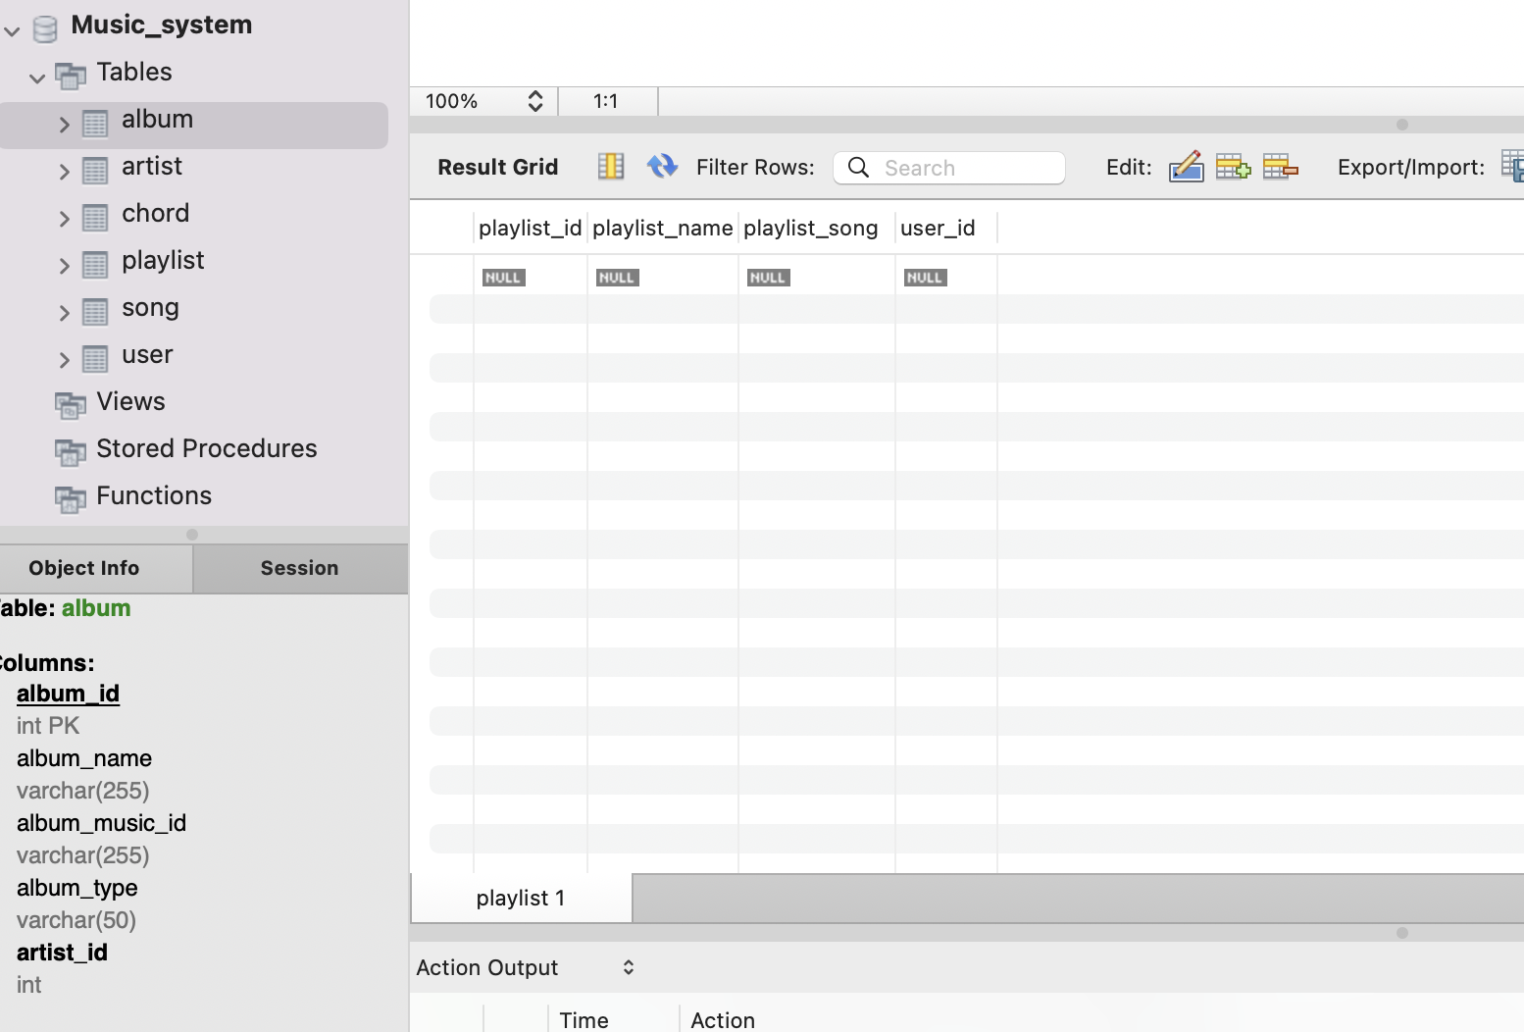

INSERT INTO playlist (playlist_id,playlist_name, playlist_song, user_id)

VALUES

(1,'Favorites', '1,3,5,7,9,11', 1),

(2,'Chill Vibes', '2,4,6,8,10,12', 2),

(3,'Rock Classics', '3,6,9,12,15', 3),

(4,'Pop Hits', '1,4,7,10,13', 4),

(5,'Indie Gems', '2,5,8,11,14', 5),

(6,'Party Anthems', '3,6,9,12,15', 6),

(7,'Road Trip Tunes', '1,4,7,10,13', 7),

(8,'Jazz Fusion', '2,5,8,11,14', 8),

(9,'Acoustic Bliss', '1,4,7,10,13', 9),

(10,'R&B Grooves', '2,5,8,11,14', 10),

(11,'Dance Party', '3,6,9,12,15', 11),

(12,'Country Hits', '1,4,7,10,13', 12),

(13,'Classical Gems', '2,5,8,11,14', 13),

(14,'Hip-Hop Vibes', '3,6,9,12,15', 14),

(15,'Reggae Roots', '1,4,7,10,13', 15);

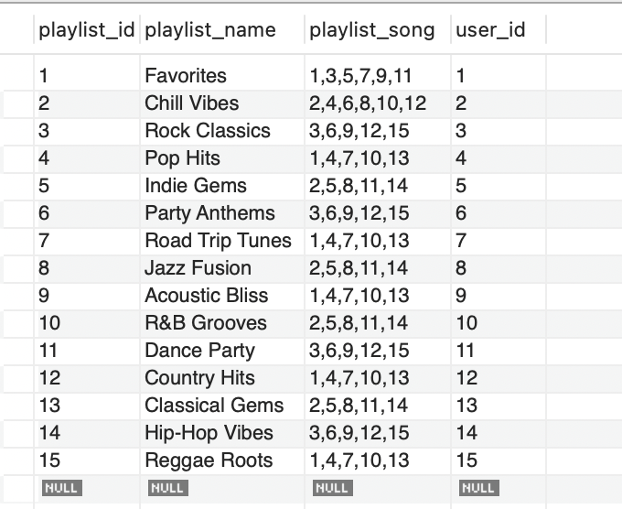

CREATE TABLE gener (

gener_id INT PRIMARY KEY,

gener_name VARCHAR(50),

description TEXT,

created_date DATE

);

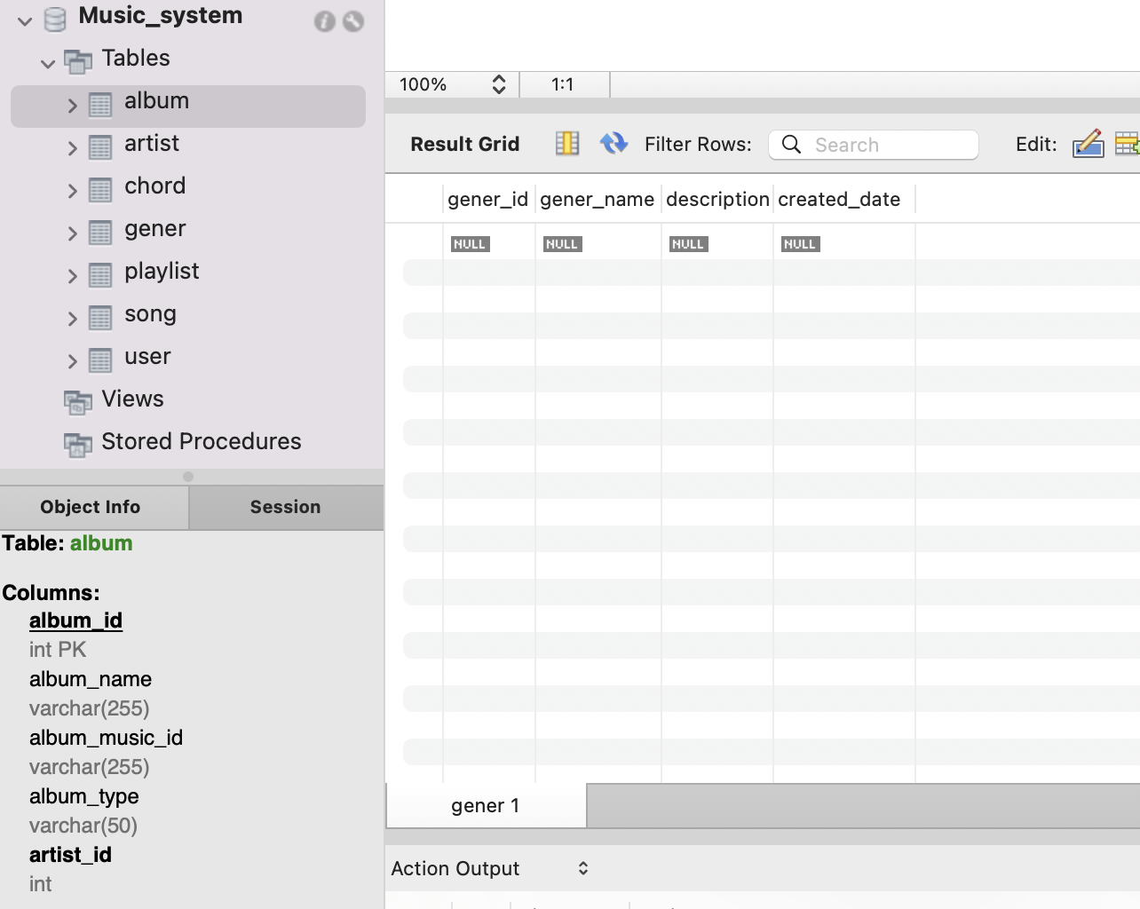

INSERT INTO gener (gener_id, gener_name, description, created_date)

VALUES

(1,'Pop', 'Popular music', '2022-01-15'),

(2,'Rock', 'Rock and roll', '2022-01-16'),

(3,'R&B', 'Rhythm and blues', '2022-01-17'),

(4,'Jazz', 'Jazz and blues', '2022-01-18'),

(5,'Hip-Hop', 'Hip-hop and rap', '2022-01-19'),

(6,'Country', 'Country and western', '2022-01-20'),

(7,'Classical', 'Classical music', '2022-01-21'),

(8,'Reggae', 'Reggae and ska', '2022-01-22'),

(9,'Blues', 'Blues and soul', '2022-01-23'),

(10,'Electronic', 'Electronic music', '2022-01-24'),

(11,'Folk', 'Folk and acoustic', '2022-01-25'),

(12,'Indie', 'Indie and alternative', '2022-01-26'),

(13,'Metal', 'Heavy metal', '2022-01-27'),

(14,'Punk', 'Punk rock', '2022-01-28'),

(15, 'World', 'World music', '2022-01-29');

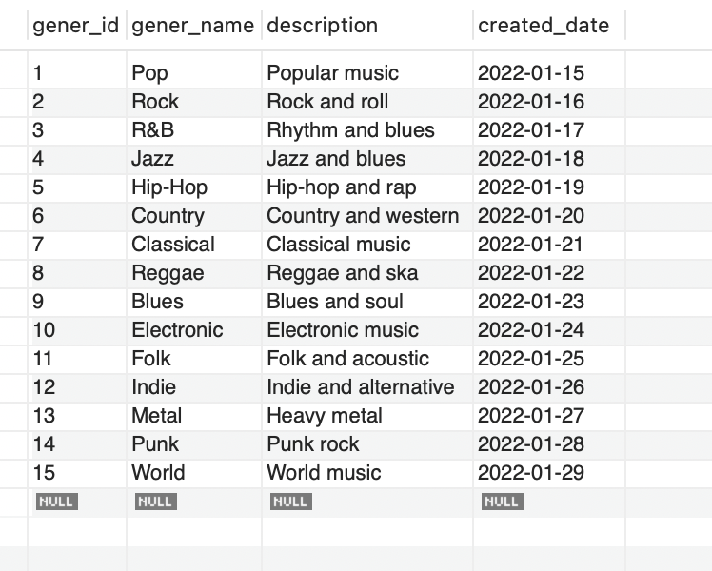

CREATE TABLE lyric (

lyric_id INT PRIMARY KEY,

song_id INT,

language VARCHAR(50),

date_created DATE,

FOREIGN KEY (song_id) REFERENCES song(song_id)

);

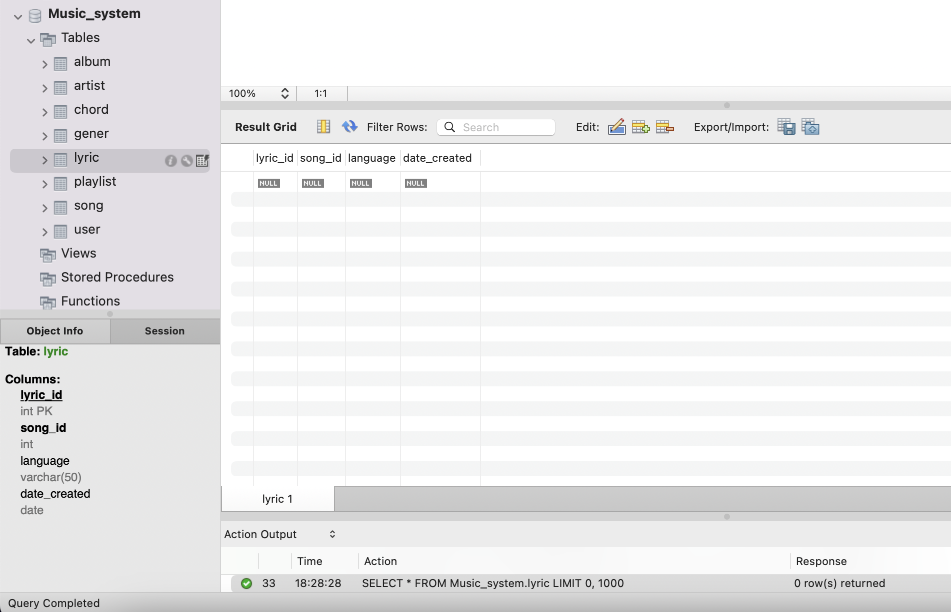

INSERT INTO lyric (lyric_id, song_id, language, date_created)

VALUES

(1,1, 'English', '2022-01-18'),

(2,2, 'English', '2022-01-20'),

(3,3, 'English', '2022-01-22'),

(4,4, 'English', '2022-01-24'),

(5,5, 'English', '2022-01-26'),

(6,6, 'English', '2022-01-28'),

(7,7, 'English', '2022-01-30'),

(8,8, 'English', '2022-02-01'),

(9,9, 'English', '2022-02-03'),

(10,10, 'English', '2022-02-05'),

(11,11, 'English', '2022-02-07'),

(12,12, 'English', '2022-02-09'),

(13,13, 'English', '2022-02-11'),

(14,14, 'English', '2022-02-13'),

(15,15, 'English', '2022-02-15');

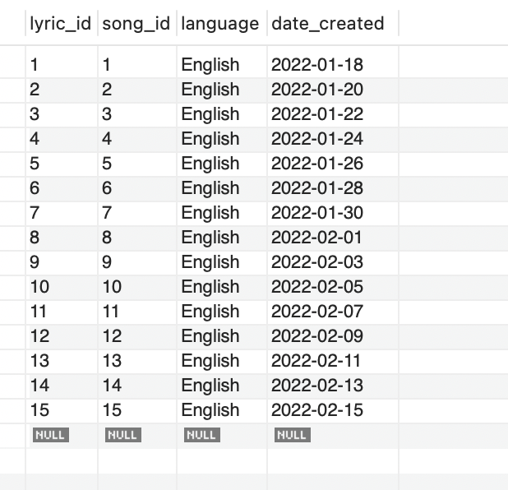

CREATE TABLE instrument (

instrument_id INT PRIMARY KEY,

instrument_name VARCHAR(255) NOT NULL,

instrument_type VARCHAR(50),

artist_id INT,

FOREIGN KEY (artist_id) REFERENCES artist(artist_id)

);

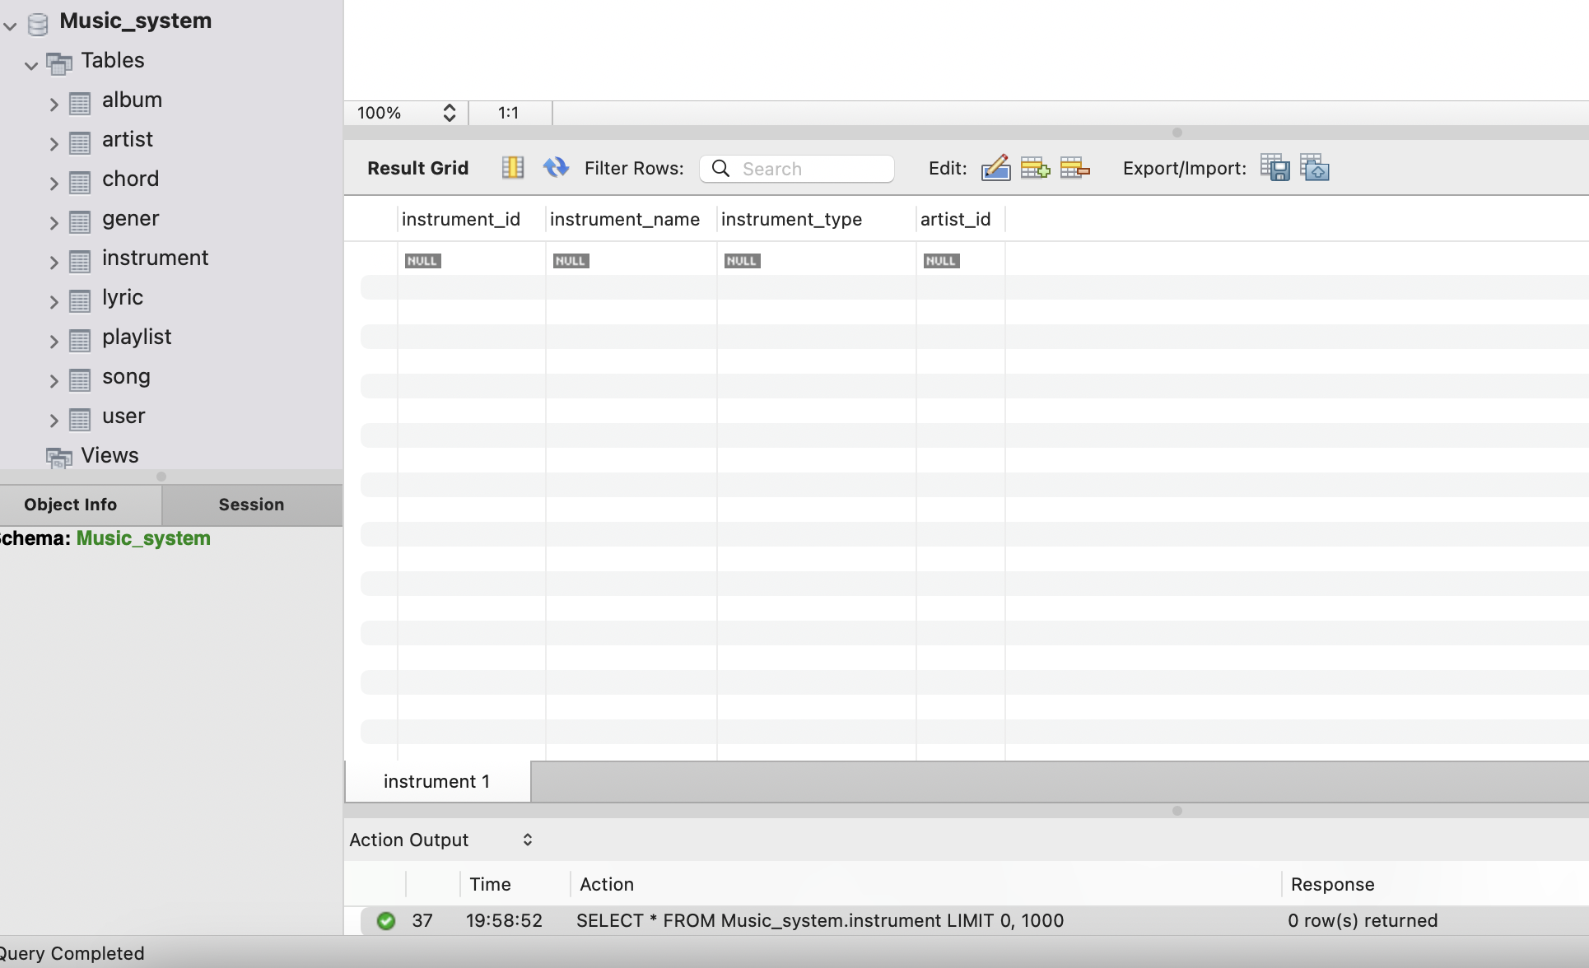

INSERT INTO instrument (instrument_id, instrument_name, instrument_type, artist_id)

VALUES

(1, 'Guitar', 'String', 1),

(2, 'Piano', 'Keyboard', 2),

(3, 'Drums', 'Percussion', 3),

(4, 'Bass Guitar', 'String', 4),

(5, 'Violin', 'String', 5),

(6, 'Trumpet', 'Brass', 6),

(7, 'Saxophone', 'Woodwind', 7),

(8, 'Flute', 'Woodwind', 8),

(9, 'Bassoon', 'Woodwind', 9),

(10, 'Harmonica', 'Wind', 10),

(11, 'Synthesizer', 'Electronic', 11),

(12, 'Accordion', 'Keyboard', 12),

(13, 'Banjo', 'String', 13),

(14, 'Xylophone', 'Percussion', 14),

(15, 'Bagpipes', 'Wind', 15);

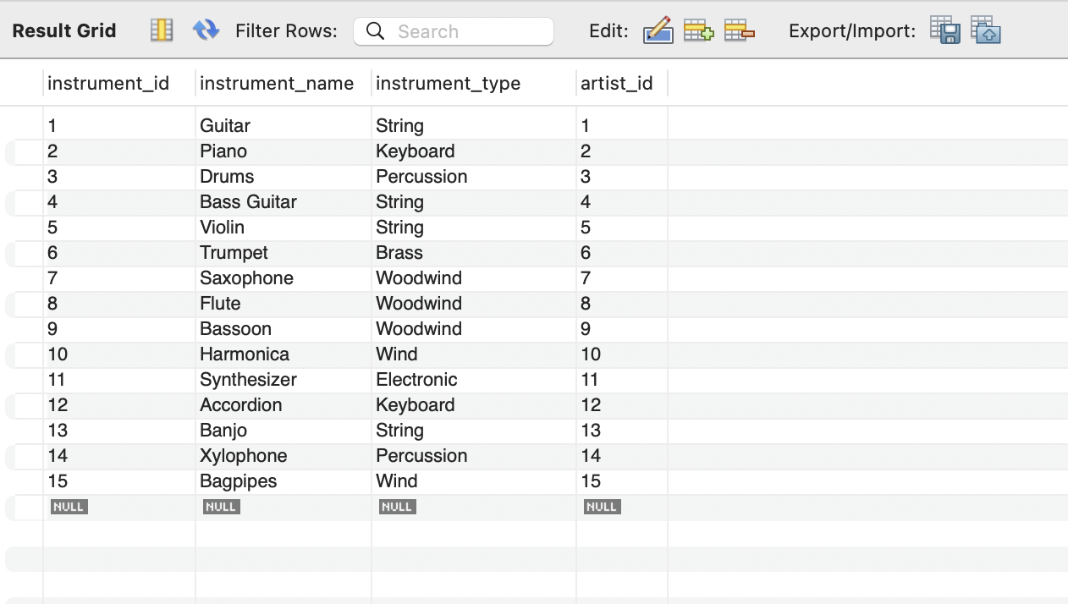

CREATE TABLE rating (

rating_id INT PRIMARY KEY,

song_id INT,

user_id INT,

rating_value INT,

comment TEXT,

date_rated DATE,

FOREIGN KEY (song_id) REFERENCES song(song_id),

FOREIGN KEY (user_id) REFERENCES user(user_id)

);

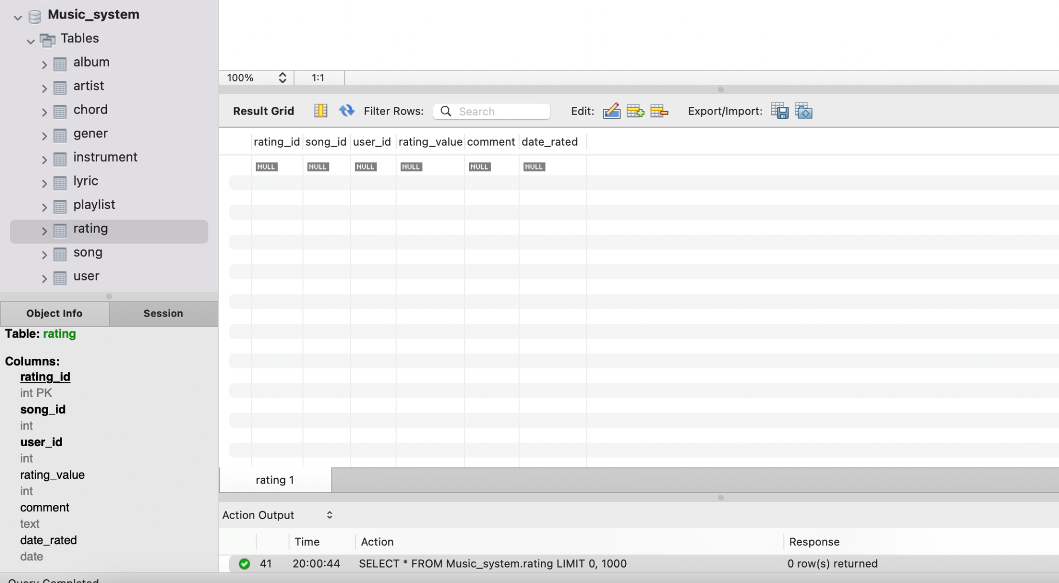

INSERT INTO rating (rating_id, song_id, user_id, rating_value, comment, date_rated)

VALUES

(1, 1, 1, 5, 'Great song!', '2022-01-18'),

(2, 2, 2, 4, 'Nice melody.', '2022-01-20'),

(3, 3, 3, 5, 'Rocking performance!', '2022-01-22'),

(4, 4, 4, 4, 'Catchy tune.', '2022-01-24'),

(5, 5, 5, 3, 'Decent song.', '2022-01-26'),

(6, 6, 6, 5, 'Awesome drumming.', '2022-01-28'),

(7, 7, 7, 4, 'Smooth sax.', '2022-01-30'),

(8, 8, 8, 4, 'Beautiful piano.', '2022-02-01'),

(9, 9, 9, 3, 'Interesting instrument.', '2022-02-03'),

(10, 10, 10, 5, 'Harmonica magic!', '2022-02-05'),

(11, 11, 1, 4, 'Cool synth sound.', '2022-02-07'),

(12, 12, 2, 3, 'Accordion vibes.', '2022-02-09'),

(13, 13, 3, 5, 'Banjo twang.', '2022-02-11'),

(14, 14, 4, 4, 'Xylophone melodies.', '2022-02-13'),

(15, 15, 5, 3, 'Bagpipes mood.', '2022-02-15');

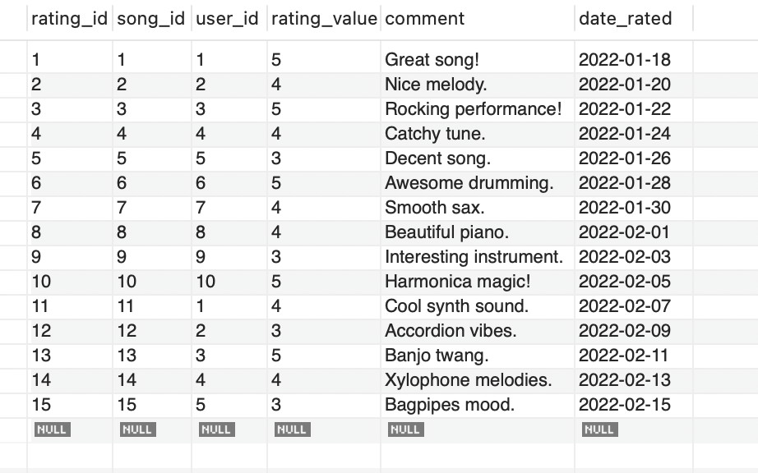

**Indexes:**

CREATE INDEX idx_artist_name ON artist (artist_name);

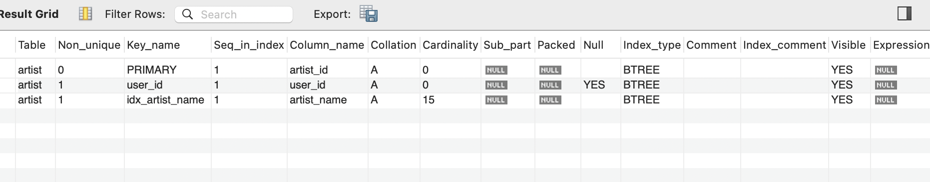

CREATE INDEX idx_song_artist ON song (artist_id, song_name);

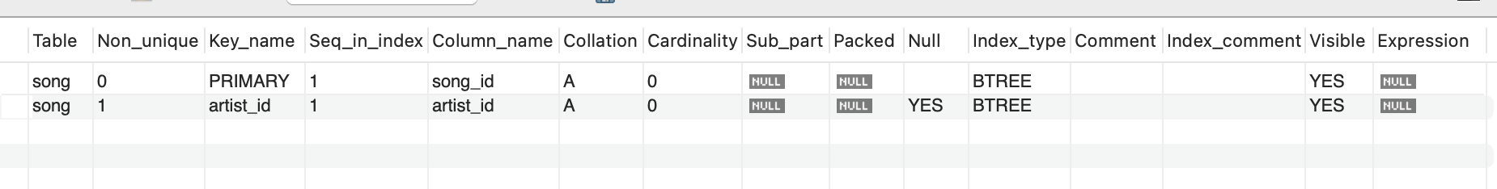

CREATE UNIQUE INDEX idx_user_email ON user (user_email);

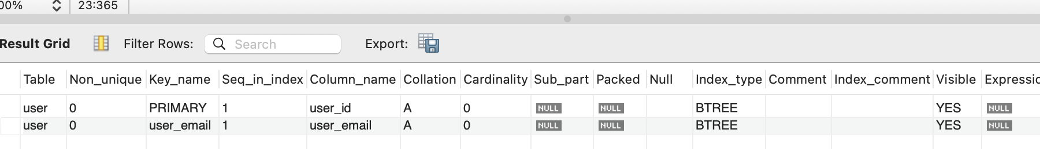

CREATE FULLTEXT INDEX idx_lyric_text ON lyric (language, lyric_text);

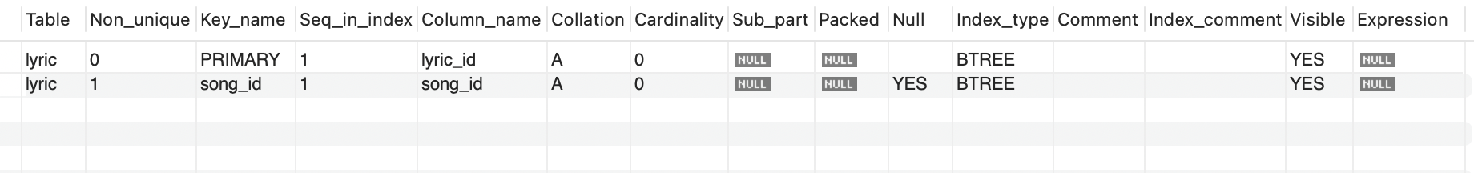

**View:**

**1. View to Show Artist Information with Instrument:**

CREATE VIEW artist_instruments AS

SELECT

a.artist_name,

a.artist_email,

i.instrument_name

FROM

artist a

LEFT JOIN

instrument i ON a.artist_id = i.artist_id;

This view combines artist information with the instruments they play.

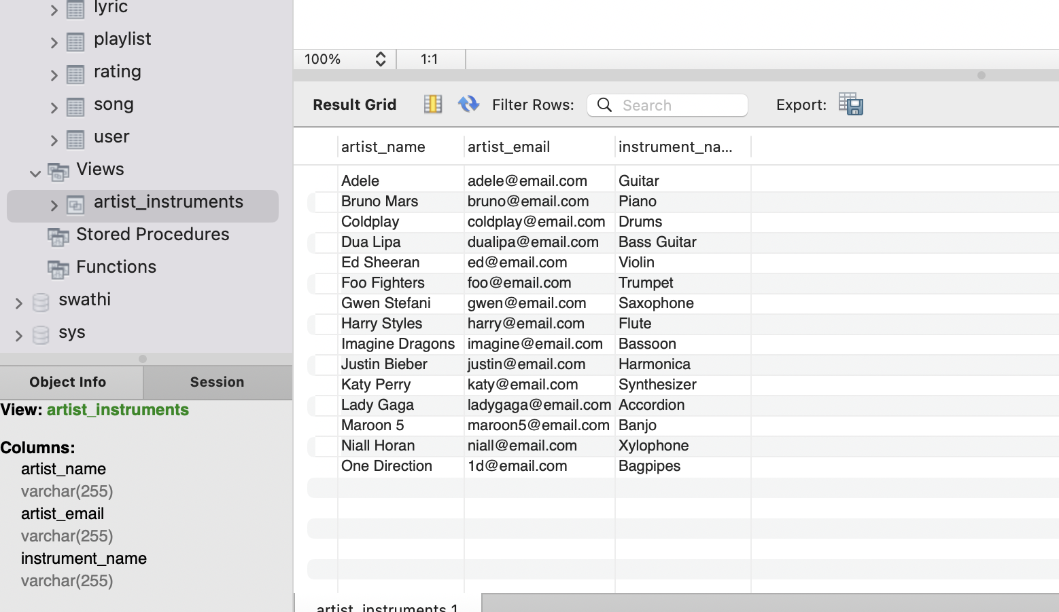

**2. View to Show Top Rated Songs:**

CREATE VIEW top_rated_songs AS

SELECT

s.song_name,

AVG(r.rating_value) AS average_rating

FROM

song s

LEFT JOIN

rating r ON s.song_id = r.song_id

GROUP BY

s.song_name

HAVING

AVG(r.rating_value) >= 4;

This view lists songs with an average rating of 4 or higher.

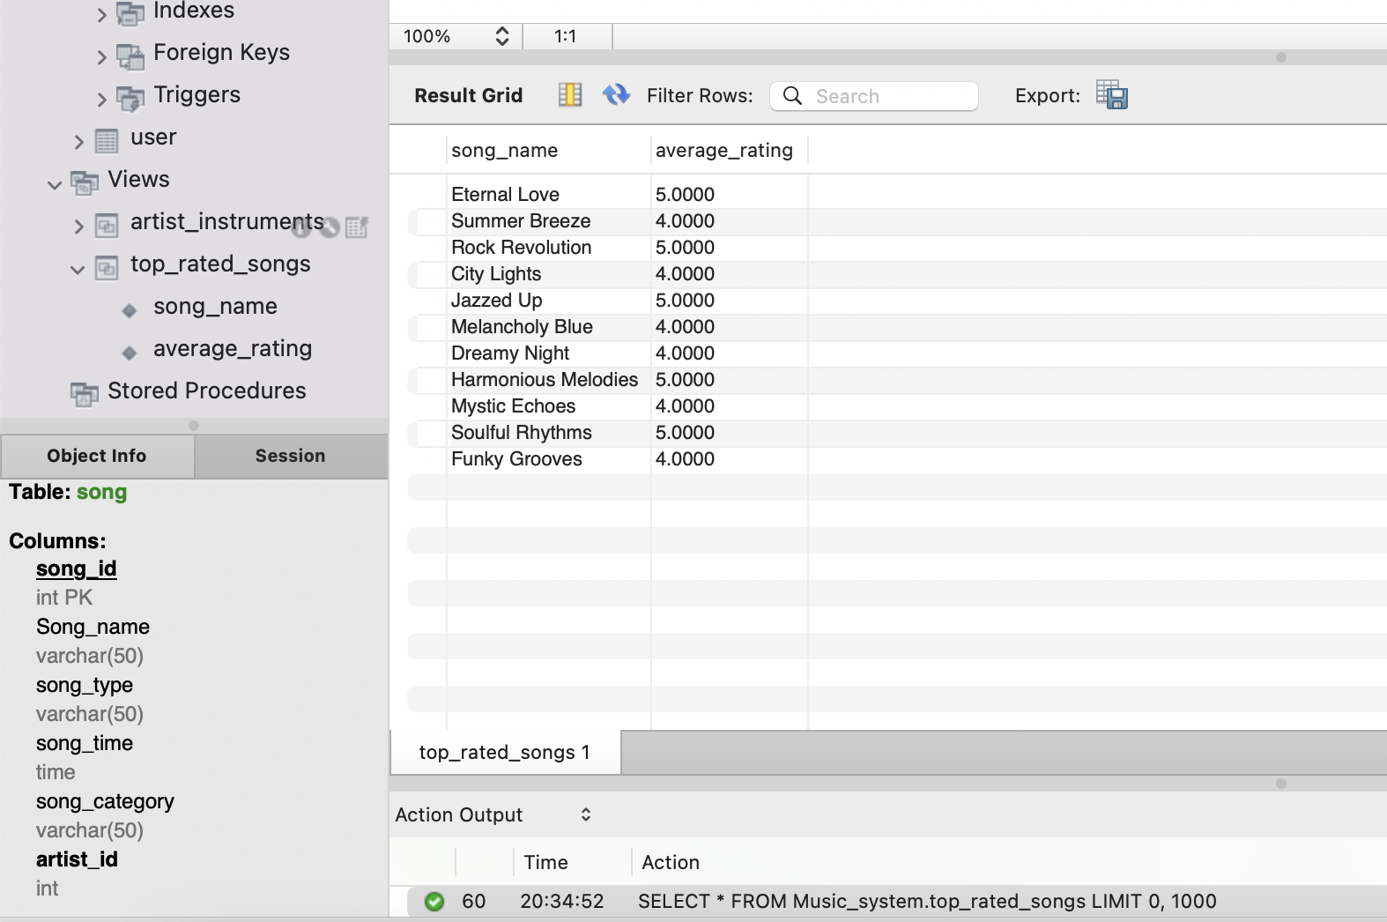

**3. View to Show Song Ratings:**  
CREATE VIEW song_ratings AS

SELECT

s.song_name,

AVG(r.rating_value) AS average_rating,

COUNT(r.rating_id) AS number_of_ratings

FROM

song s

LEFT JOIN

rating r ON s.song_id = r.song_id

GROUP BY

s.song_name;

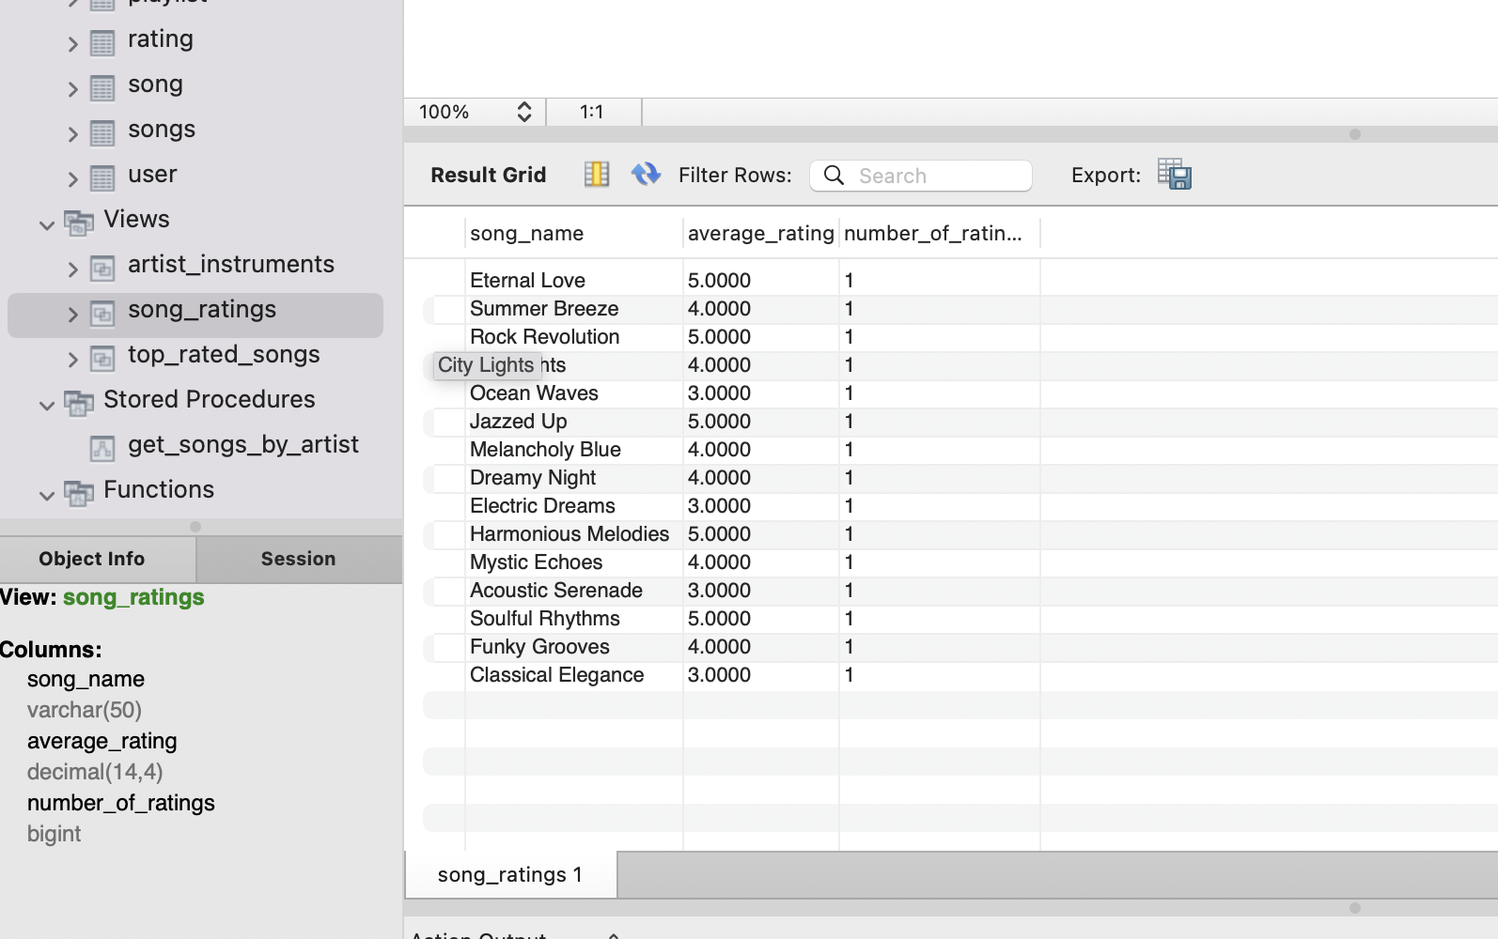

**4. View to Show Top Artists by Number of Songs:**

CREATE VIEW top_artists_by_songs AS

SELECT

a.artist_name,

COUNT(s.song_id) AS number_of_songs

FROM

artist a

LEFT JOIN

song s ON a.artist_id = s.artist_id

GROUP BY

a.artist_name

ORDER BY

number_of_songs DESC;

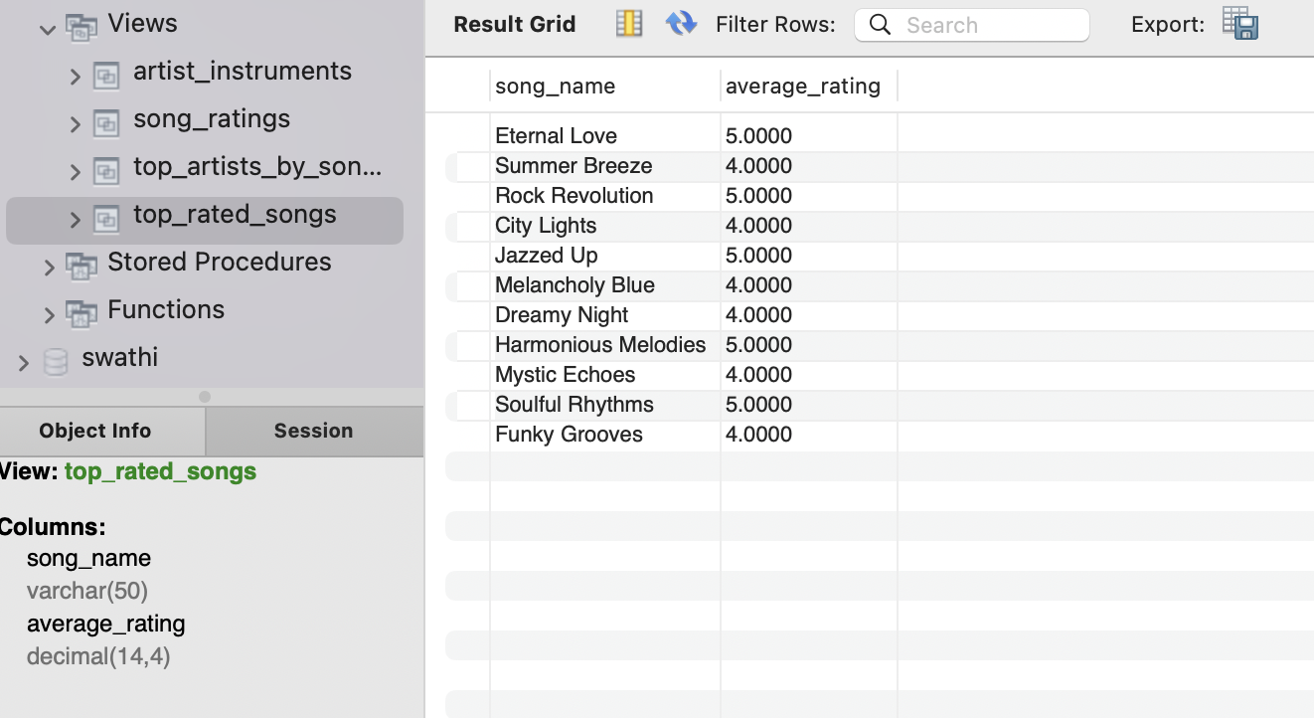

**5. View to Show Songs by Genre:**

CREATE VIEW songs_by_genre AS

SELECT

gener_name,

song_name

FROM

gener

LEFT JOIN

song ON gener_id = gener_id;

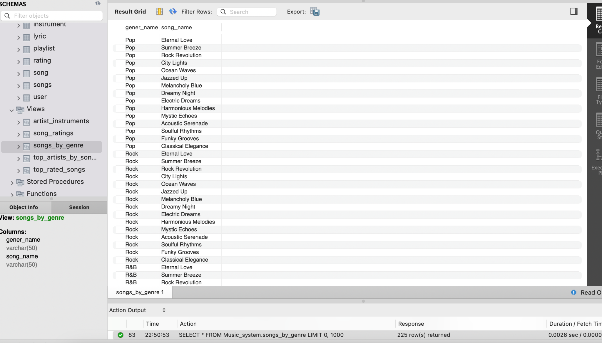

**Temporary table:**

1. CREATE TEMPORARY TABLE temp_table AS SELECT * FROM user;

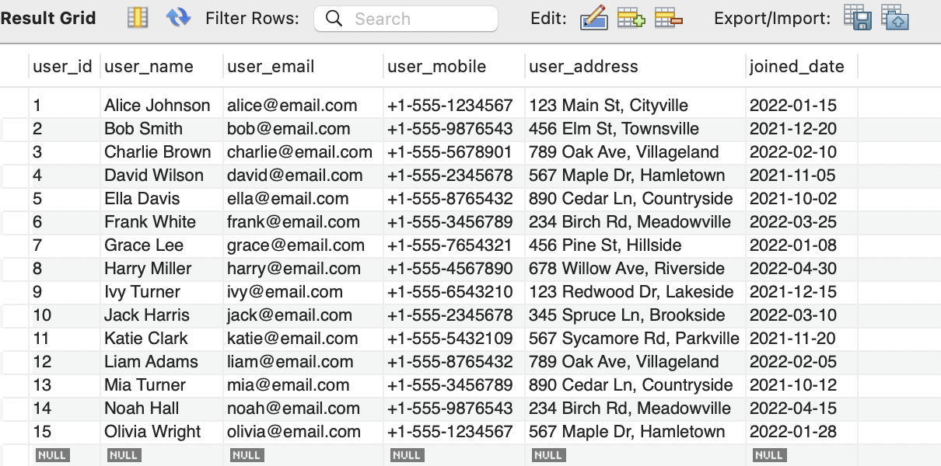

1. CREATE TEMPORARY TABLE temp_table_lyric AS SELECT * FROM lyric;



1. CREATE TEMPORARY TABLE temp_table_song AS SELECT * FROM song;



1. CREATE TEMPORARY TABLE temp_table_gener AS SELECT * FROM gener;



**Triggers:**

1. **Trigger to log song change:**

DELIMITER $$

CREATE TRIGGER log_song_changes

AFTER INSERT ON song

FOR EACH ROW

BEGIN

INSERT INTO song_change_log (song_id, change_type, change_date)

VALUES (NEW.song_id, 'INSERT', NOW());

END $$

DELIMITER ;

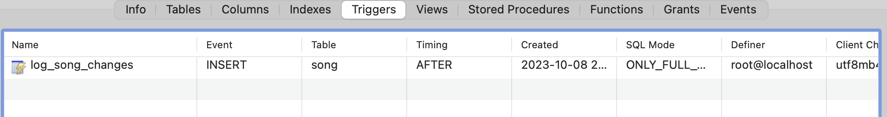

**2. Trigger to Enforce Data Consistency:**

DELIMITER $$

CREATE TRIGGER enforce_album_type_consistency

BEFORE INSERT ON album

FOR EACH ROW

BEGIN

DECLARE artist_gender VARCHAR(10);

SELECT artist_gender INTO artist_gender FROM artist WHERE artist_id = NEW.artist_id;

IF NEW.album_type != artist_gender THEN

SIGNAL SQLSTATE '45000'

SET MESSAGE_TEXT = 'Album type does not match artist gender.';

END IF;

END $$

DELIMITER ;

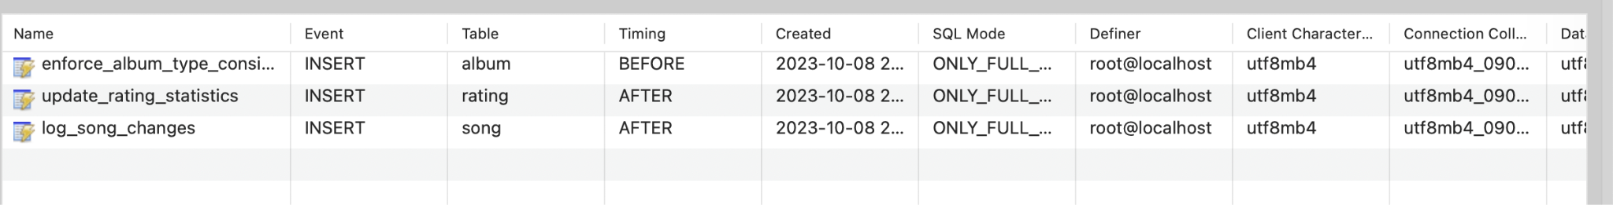

**3. Trigger to Update Statistics:**

DELIMITER $$

CREATE TRIGGER update_rating_statistics

AFTER INSERT ON rating

FOR EACH ROW

BEGIN

UPDATE song

SET song_rating = (SELECT AVG(rating_value) FROM rating WHERE song_id = NEW.song_id)

WHERE song_id = NEW.song_id;

END $$

DELIMITER ;



**Stored procedure:**

1. **To retrieve songs by an artist**

DELIMITER $$

CREATE PROCEDURE get_songs_by_artist(IN artist_id INT)

BEGIN

SELECT * FROM song WHERE artist_id = artist_id;

END $$

DELIMITER ;

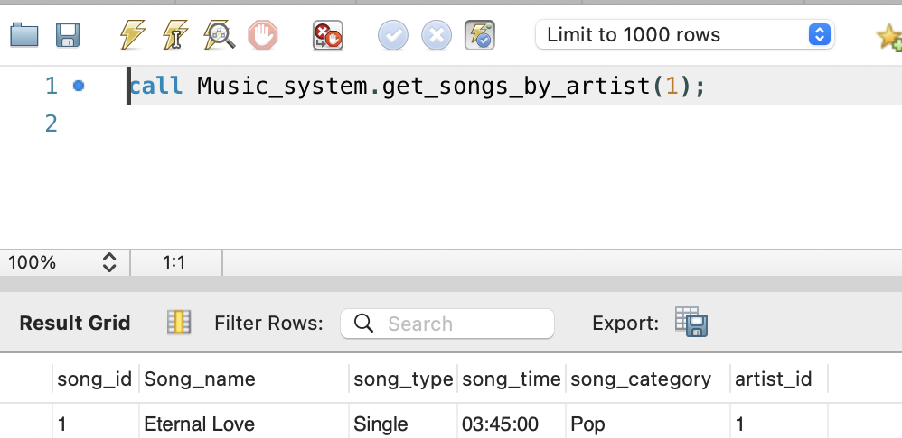

1. **To Add a New Song:**

DELIMITER $$

CREATE PROCEDURE add_new_song(

IN song_name VARCHAR(255),

IN song_type VARCHAR(50),

IN song_time INT,

IN song_category VARCHAR(50),

IN artist_id INT

)

BEGIN

INSERT INTO song (song_name, song_type, song_time, song_category, artist_id)

VALUES (song_name, song_type, song_time, song_category, artist_id);

END $$

DELIMITER ;

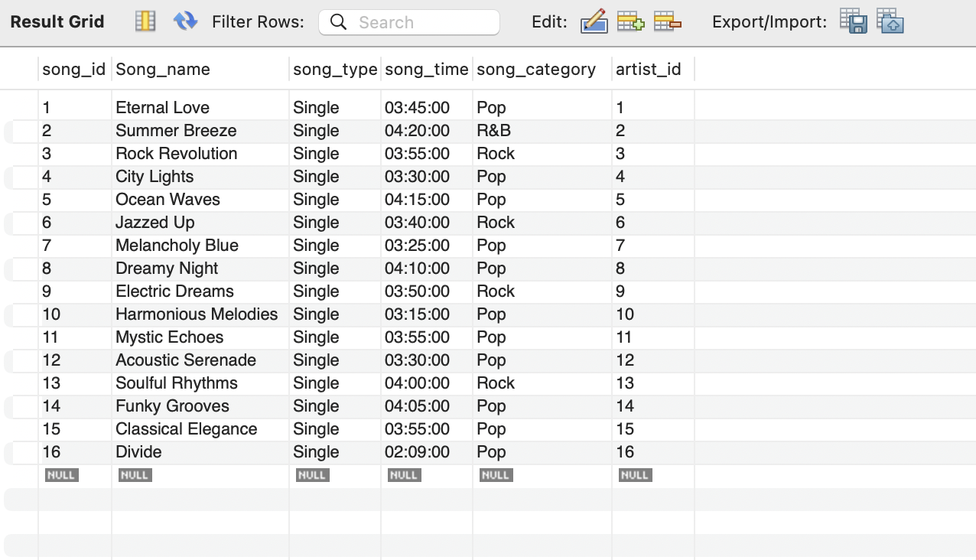

1. **To Delete a Playlist:**

DELIMITER $$

CREATE PROCEDURE delete_playlist(IN playlist_id INT)

BEGIN

DELETE FROM playlist WHERE playlist_id = playlist_id;

END $$

DELIMITER ;

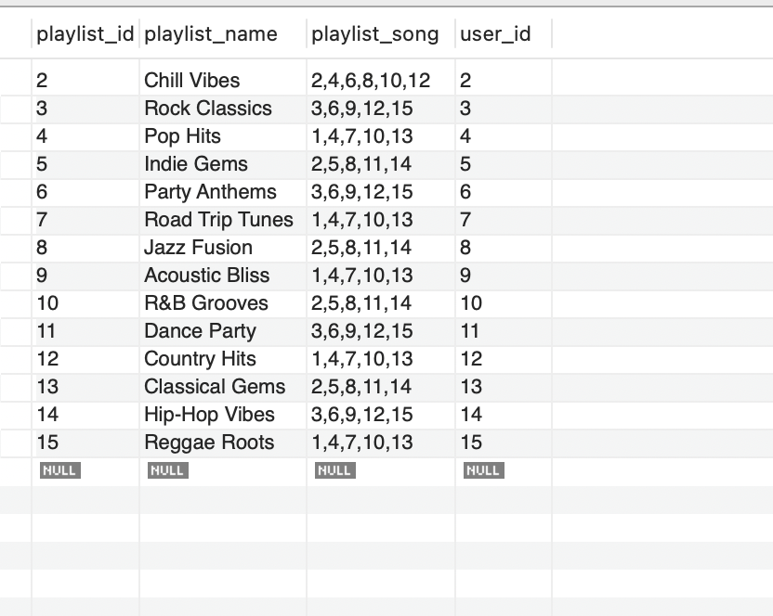

1. **To Calculate Song Duration:**

DELIMITER $$

CREATE PROCEDURE calculate_song_duration(IN song_id INT)

BEGIN

DECLARE song_duration VARCHAR(20);

SELECT CONCAT(FLOOR(song_time / 60), 'm ', song_time % 60, 's') INTO song_duration FROM song WHERE song_id = song_id LIMIT 1;

SELECT song_duration AS 'Song Duration';

END $$

DELIMITER ;

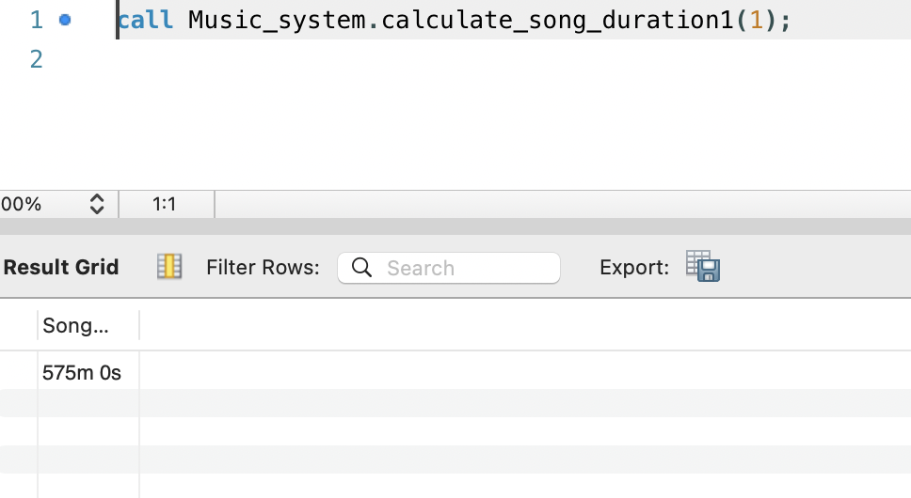

**Functions:**

1. **To find avg rating:**

DELIMITER $$

CREATE FUNCTION calculate_average_rating(song_id INT)

RETURNS DECIMAL(3,2)

DETERMINISTIC

READS SQL DATA

BEGIN

DECLARE avg_rating DECIMAL(3,2);

SELECT AVG(rating_value) INTO avg_rating FROM rating WHERE song_id = song_id;

RETURN avg_rating;

END $$

DELIMITER ;

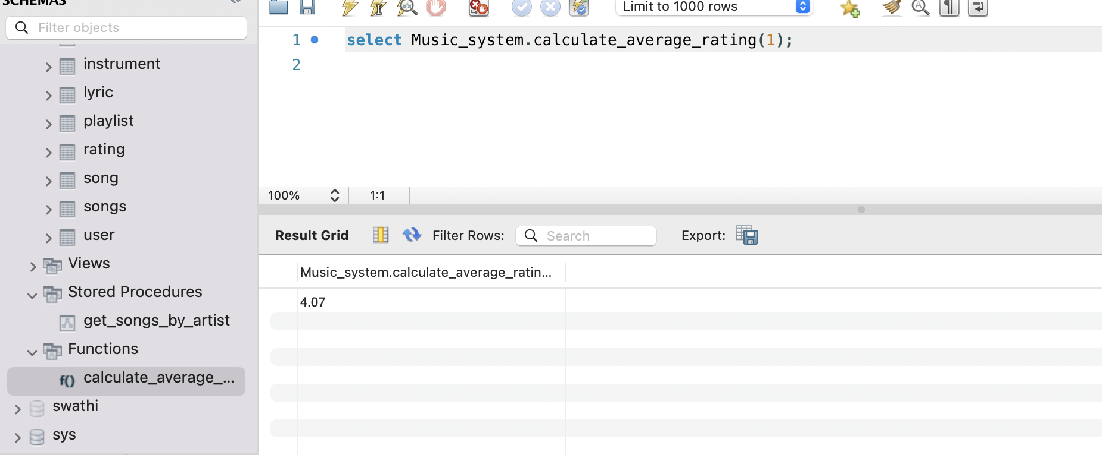

**2. To find most recent album:**

DELIMITER $$

CREATE FUNCTION count_songs_by_artist(artist_id INT)

RETURNS INT

READS SQL DATA

BEGIN

DECLARE song_count INT;

SELECT COUNT(*) INTO song_count FROM song WHERE artist_id = artist_id;

RETURN song_count;

END $$

DELIMITER ;

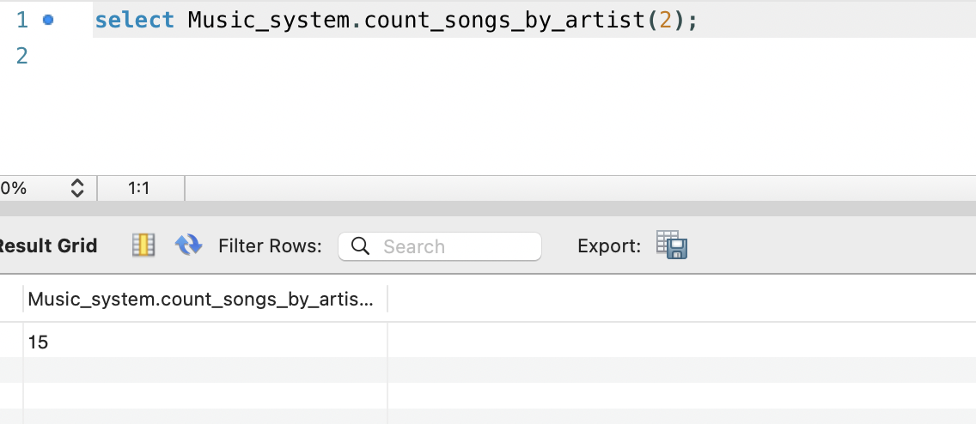

**3. To check if song has lyrics:**

DELIMITER $$

CREATE FUNCTION has_lyrics(song_id INT)

RETURNS BOOLEAN

BEGIN

DECLARE has_lyrics_flag BOOLEAN;

SELECT COUNT(*) INTO has_lyrics_flag FROM lyric WHERE song_id = song_id;

RETURN IF(has_lyrics_flag > 0, TRUE, FALSE);

END $$

DELIMITER ;

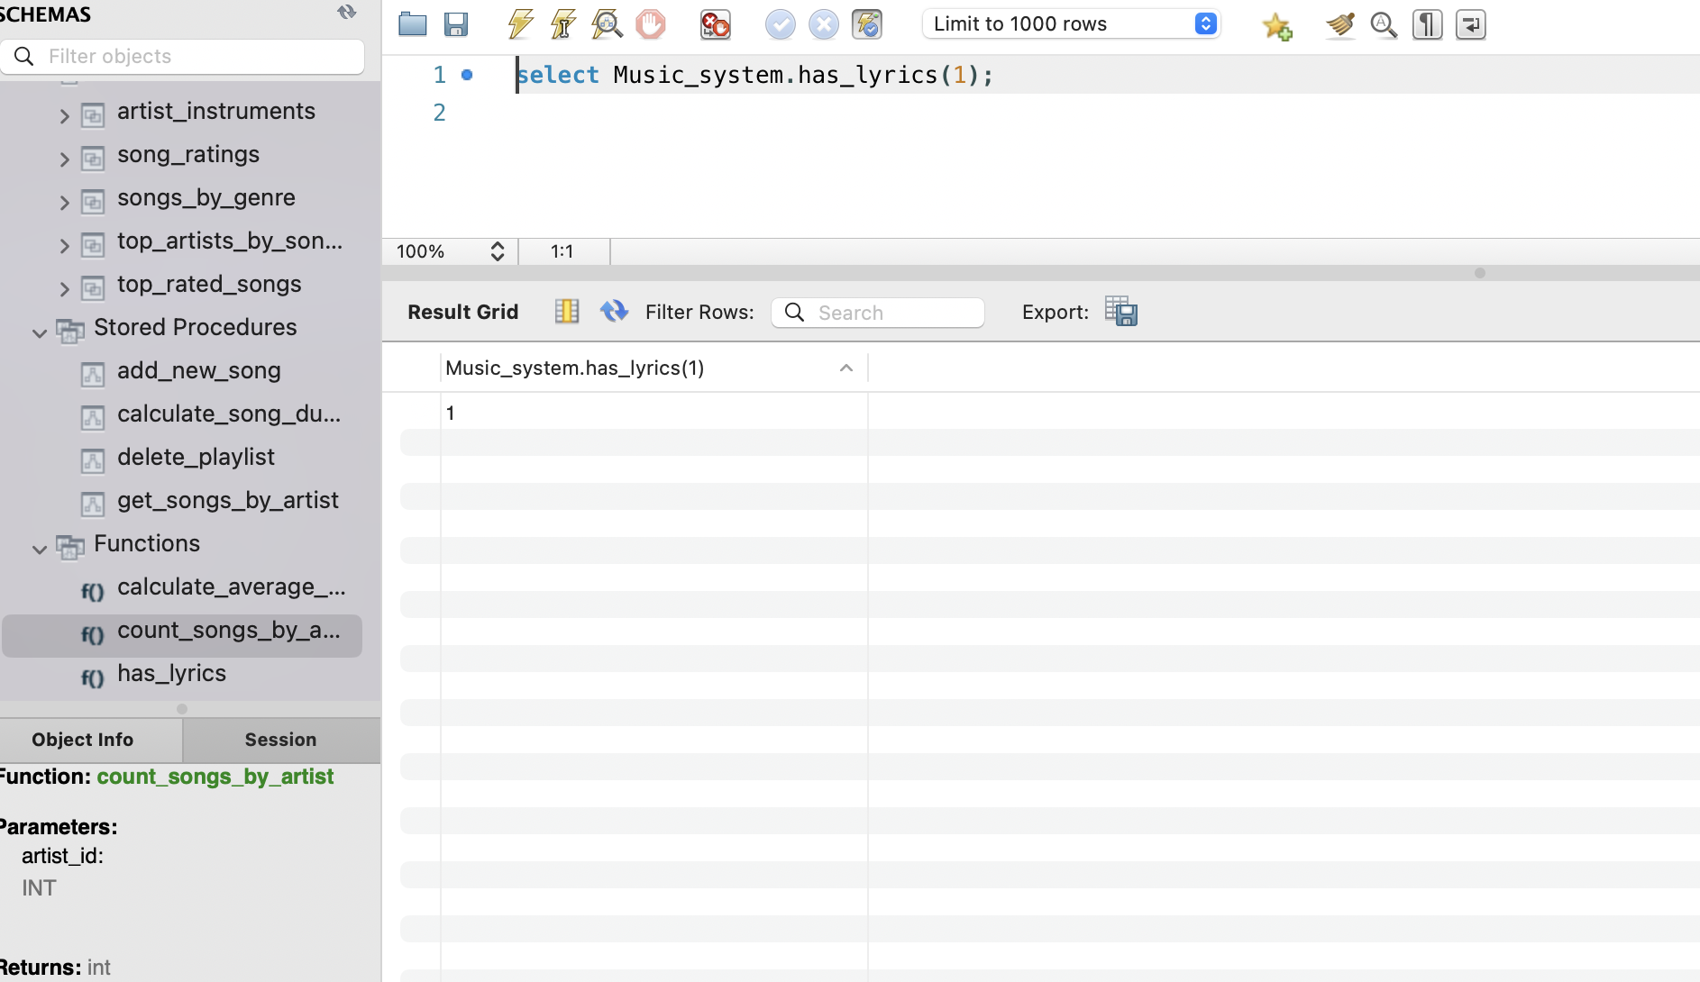

**Team G**

1. Swathi Yadlapalli - A20545355
2. Sai Sivani Dukkipati - A20547981
3. Nallagangula Venkata Kishore Kumar Reddy - A20545723
4. Molli Venkata Naga Satya Dinesh Datta - A20546385
5. Sanjana Reddy- A20550437